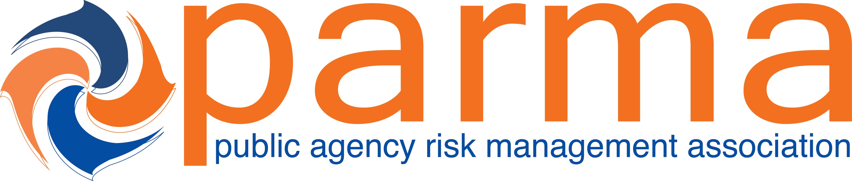

Session Title: F1 - Breaking Down the Most Significant Appellate Decision Since SB899: How Lindh Brought Law & Order to the Apportionment Wild West

CE Credits Earned: 1.25

Presented To:____________________________________________________________Date:_______________________

Certificate of Attendance from the 2021 Public Agency Risk Management Association Conference

_________________________________________
Catherine Jones, PARMA President

The recipient earned Continuing Education Credits in accordance with the guidelines established by the National Task Force on Continuing Education for completion of the program.

