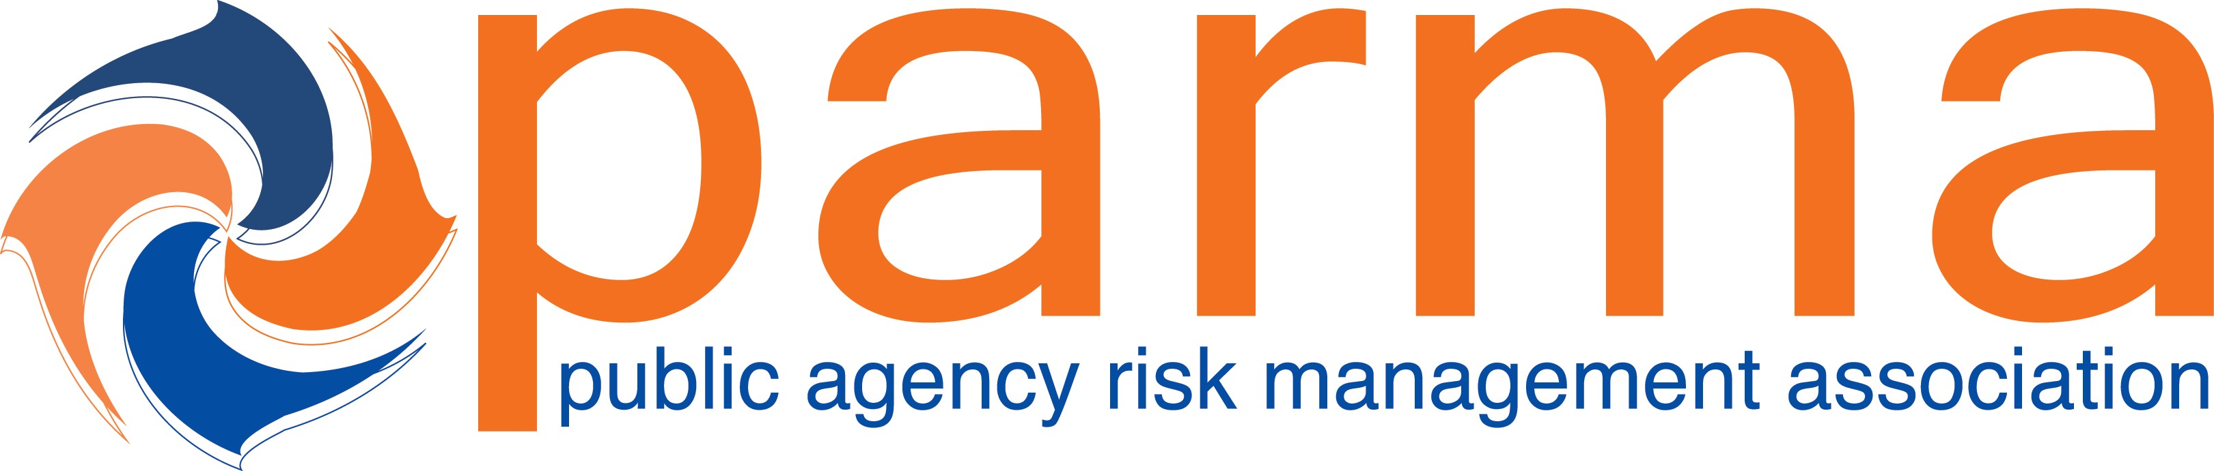

Session Title: E6 - Coverage for Claims By Employees – Gaps and Overlaps Typical Coverages and what the Coverages Provide and Don’t Provide

CE Credits Earned: 1.5

Presented To:____________________________________________________________Date:_______________________

Certificate of Attendance from the 2021 Public Agency Risk Management Association Conference

_________________________________________
Catherine Jones, PARMA President

The recipient earned Continuing Education Credits in accordance with the guidelines established by the National Task Force on Continuing Education for completion of the program.

